Product Requirements Document (PRD)
Global Tech Forecast & AI-Enabled AFE Platform
Version 4.2 – Detailed Draft

1. Executive Summary
This initiative modernizes Global Technology’s financial planning and capital governance by replacing macro-driven spreadsheets with a structured Forecast Planning-Budget Actuals application, seamlessly integrated with an AI-enabled AFE (Authorization for Expenditure) Intake process—an automated workflow for submitting and approving project requests. The platform leverages data automation and intelligent workflows to improve accuracy and efficiency.
MVP establishes:
Financial Planning-Forecast App:
- Foundation app – Role based Forecast/Budget/Actuals application capturing Labor, Software, Hardware, Capital and other Operating expenses
- Cross-cost center orchestration – automates coordination between different cost centers, eliminating manual communication and reducing errors.
- Resource requests workflow – streamlines the process for requesting additional personnel or assets, ensuring requests are tracked and approved efficiently.
- Resource actuals report ingestion from Workday – integrates workforce data from Workday, allowing for accurate tracking of resource costs.
- Actuals via SAP A40 ingestion – enables automated data import from SAP via an A40 (MS Office connector), to provide up-to-date financial actuals for planning and reporting.
Approval and Governance:
- AI-assisted executive business case narrative – supports leaders in crafting compelling business cases for their AFE requests, leveraging AI to enhance clarity and impact.
- Structured approval workflows – enforces consistent, auditable steps for reviewing and approving expenditures, ensuring compliance and transparency.
- Immutable executive memo output with audit – produces executive memos that are locked and auditable, maintaining a permanent record of decisions and approvals.

2. Target Operating Model
The platform separates two linked lifecycles:
Forecast Lifecycle (Continuous Planning):
ForecastSet → ForecastVersion → ForecastLineItem
Status Flow:
Draft → Submitted → Ready for Approval → Locked → Approved
- Rejected state goes to Budget Owner queue, with a request for changes. Ability to request information without rejecting
- Dual confirmation required to move to Ready for Approval (Budget Owner + Finance).
- Locked state routes to approval chain. Approved state is immutable.
AFE Lifecycle (Discrete Capital Authorization):
AFE Draft → Submitted → In Review → Approved / Rejected
At AFE submission:
• ForecastVersion snapshot is captured.
• Project slice financial summary is generated.
• AI-generated executive memo is versioned and stored.
Approved AFE is immutable.

3. Resource Requests & Actuals (Operating Workflow)
This section expands the Target Operating Model to include (1) a Resource Requests workflow for incremental personnel and (2) Workday resource actuals ingestion to validate resource start and end dates with workforce system-of-record data. These capabilities are designed to reduce manual coordination, improve auditability, and enable timely variance analysis.
3.1 Resource Requests workflow
- Purpose: Streamlines the process of requesting additional personnel and ensures requests are tracked and approved efficiently.
- Trigger: A Budget Owner identifies incremental headcount while building an AFE or when projecting their annual Forecast.
- Request capture: Request includes (at minimum) cost center, project, role/labor category, location/country, start/end dates, quantity (headcount or units), and funding type (CapEx/OpEx) based on established financial guidelines/rulebook.
- Workflow: TBD after more process review discussions
- Status tracking: Each request is logged with submit timestamp, approver, decision (approved/rejected), and decision date to support reporting and auditability.
- Forecast impact: Approved requests create or update the relevant forecast line items (or unlock the ability to add incremental labor) so that planned dollars are consistent with approved resourcing.
3.2 Workday resource actuals ingestion
- Purpose: Integrates workforce data from Workday (via reports ingestion) to enable accurate tracking of resource costs versus forecast and planned vs actual hire dates.
- Ingestion: Resource actuals reports are ingested from Workday (via reports ingestion) and associated back to planning dimensions (e.g., cost center, worker type, role where available, country/location, and time period).
- Reconciliation: The application compares Workday actuals to forecasted labor costs to surface variances by cost center, project, role, and month.
- Operational usage: Variance visibility informs in-cycle reforecasting, highlights over/under-allocation trends, and supports Head of Resource Mgt or Finance review during the Submitted → Ready for Approval stages.
- Controls: Ingested actuals are read-only in the planning experience; changes to forecast remain auditable through the ForecastVersion lifecycle.

4. Forecast Architecture & Data Model
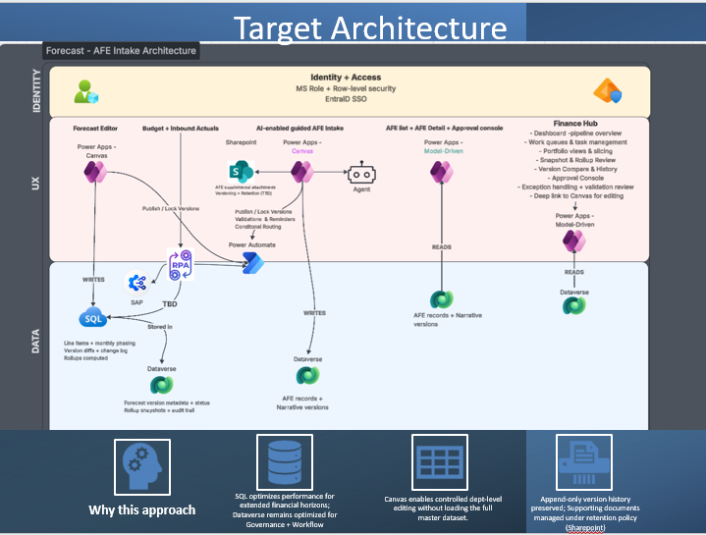

**Pending data process flow analysis & complete data capture**
Data Hierarchy:
ForecastSet → ForecastVersion → ForecastLineItem
ForecastLineItem Attributes:
• CostCenterID
• ProjectID (required; RTB auto-generated if missing)
• SectionType
• LaborCategory (FTE / Contractor)
• Incrementality (Non-Incremental / Incremental)
• CapEx / Expense flag
• Role
• Country
• Headcount (Incremental only)
• Allocation % (Non-Incremental only)
• RateSource
• Rate
• Monthly time-series records
ProjectID is mandatory prior to moving to Ready for Approval.

5. UX Model
- Role based views, ie. different screen layout for Budget Owner vs Finance Operator
- Plan, Budgets and Actuals- Difference in an editable state based on workflow lifecycle and role. Example, once actuals are ingested, those are non-editable for Budget Owners
- Figma mocks are in the Appendix

6. Labor Model
Non-Incremental Labor:
• Allocation % drives cost.
• Dollars derived from Allocation × Rate.
• Allocation >100% per resource per month is blocking.
Incremental Labor:
• Headcount-based planning.
• Role + Country required.
Contractor Rate Logic:
• AI-Agent Contractor Rate GPT already created - embed into application
• Provide Budget Owners an easy & quick way to pull rates for incremental headcount
Default = Highest Vendor Rate by Role + Country.
• Override allowed (Vendor selected or Manual), flagged in Finance view.
• Manual overrides visible and auditable.

7. Validation & Governance Rules
Blocking:
• Missing ProjectID
• Allocation >100%
• Missing required role/country/headcount
• Missing governance-required metadata
• Required attachments missing
Warnings:
• Manual rate override used
• Large variance vs prior version
• Allocation <100% (configurable)
Approved versions are immutable.
All changes are append-only and auditable.

8. Versioning Strategy – Critical Architecture Decision
Option A – Linear Versioning:
• Drafts created only from latest Approved or current Draft.
• Simple lineage.
• Lower complexity and storage impact.
Option B – Branching Versioning:
• Authorized users may create Draft from Locked or Approved version.
• Tree-based lineage with ParentVersionID.
• Greater flexibility; increased complexity and storage.
Storage Impact Placeholder Model:
Estimated additional storage per branch ≈ L × M × S
Where:
L = average line items
M = months stored
S = storage per month record
Final decision pending review.

9. Approval Workflow
Approval chain:
VP Finance → L1 → CIO → SVP Finance Controller
All must approve for version to move to Approved.
Rejection returns version to Submitted.
Questions do not change status.
Locked state triggers routing to approval queue.

10. AI-Enabled AFE Integration
AI Writing Assist available on all narrative fields.
• User-triggered only
• Append-only versioning
• Cannot modify structured financial data
Executive Memo (PDF) generated post-approval containing:
• Narrative
• ForecastVersion ID
• Project slice summary
• Snapshot totals
• Risk level
• Routing summary
Accessible to Budget Owner, Finance, and Governance.

11. Cross-Cost Center Orchestration
• Cross-Cost Center Request Engine
• Structured Cost Center Owner Workflow
• Automated Line Item Synchronization across individual Cost Center forecast/budget
• Reconfirmation Trigger on Project Change
• Dependency Tracker

12. Assumptions
• Agile development approach leveraging AI testing & possible code generation
• SQL + Dataverse hybrid architecture.
• Branching restricted to authorized users.
• Reporting defaults to latest Approved canonical version.
• Regulatory constraints to be confirmed.
• Storage limits to be validated.

13. Open Decisions Before Architecture Lock
1. Select Versioning Model (A or B).
2. Confirm storage limits and any regulatory constraints.
3. Define branch governance policy.
4. Confirm version comparison scope in Phase 1.
No schema or lifecycle implementation will be finalized until versioning strategy is confirmed.

14. Appendix – Figma Design Mocks

Dashboard –Finance and Budget Owner View
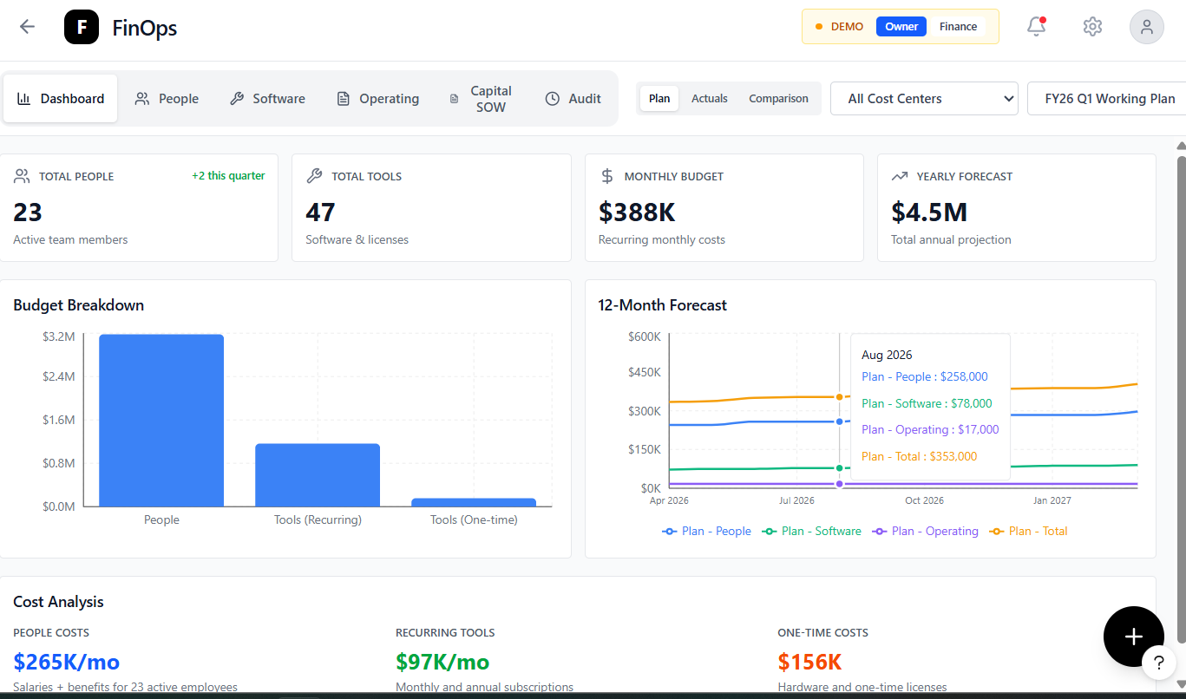

Dashboard Comparison – Budget Owner View
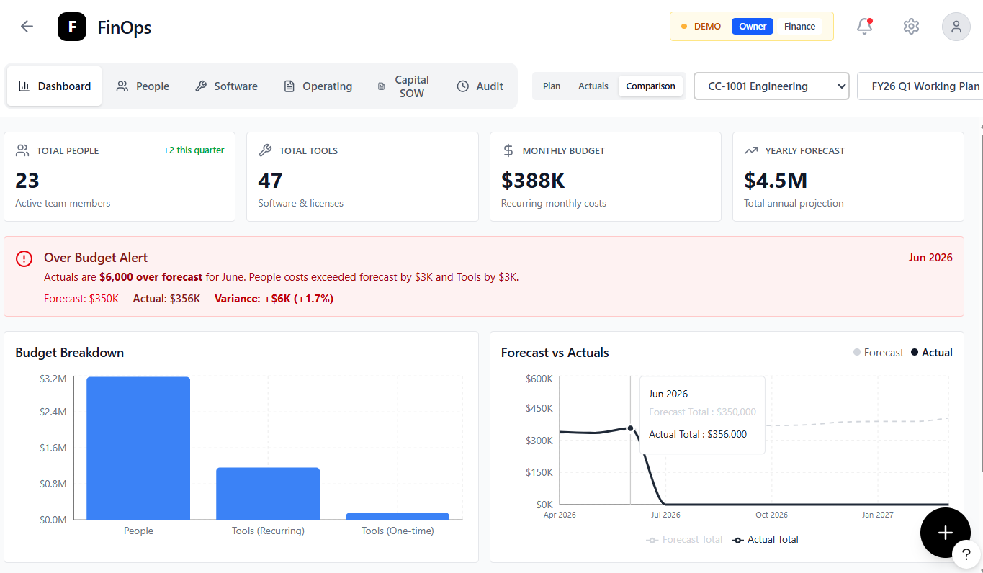

Dashboard Quick Actions
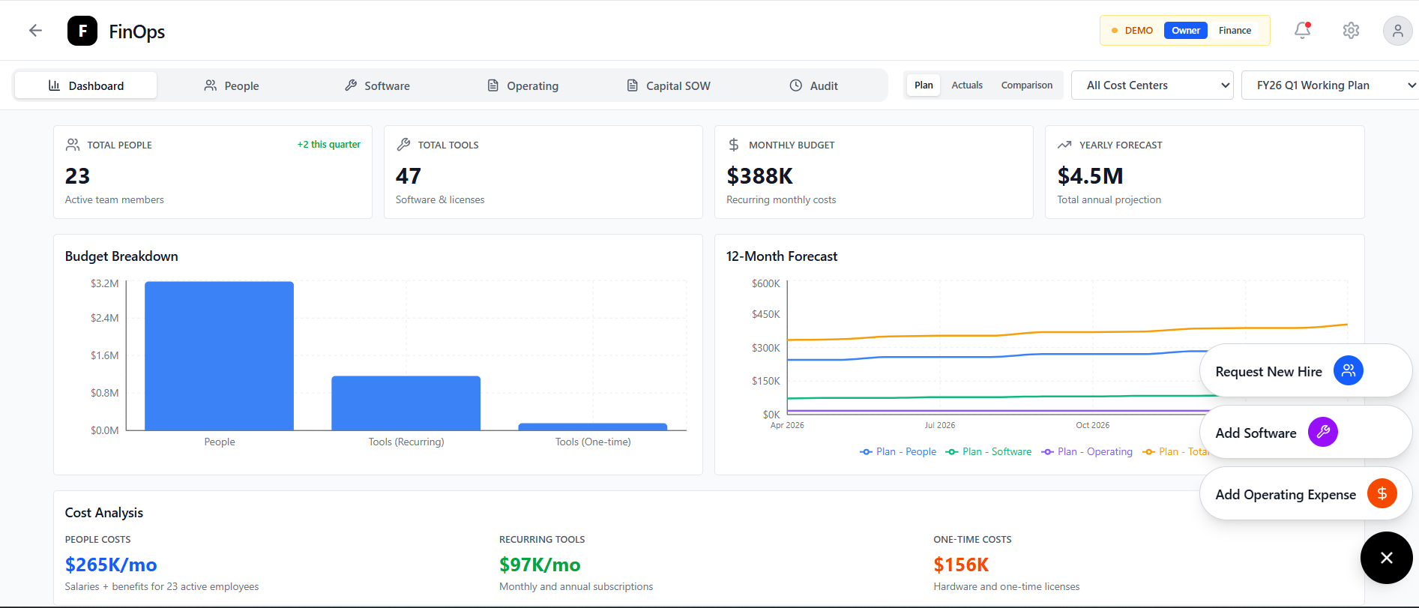

Budget Owner: People – Hiring Requests
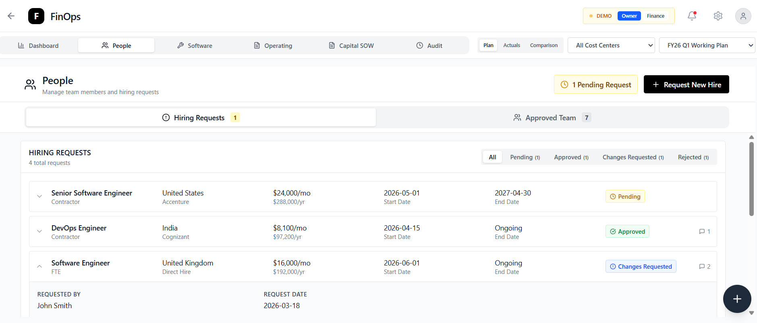

Budget Owner: People – Approved Team
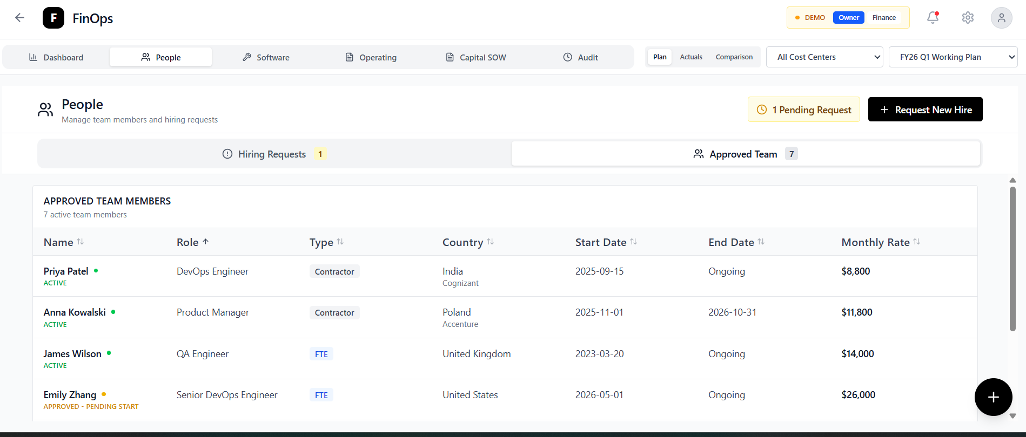

Finance: People
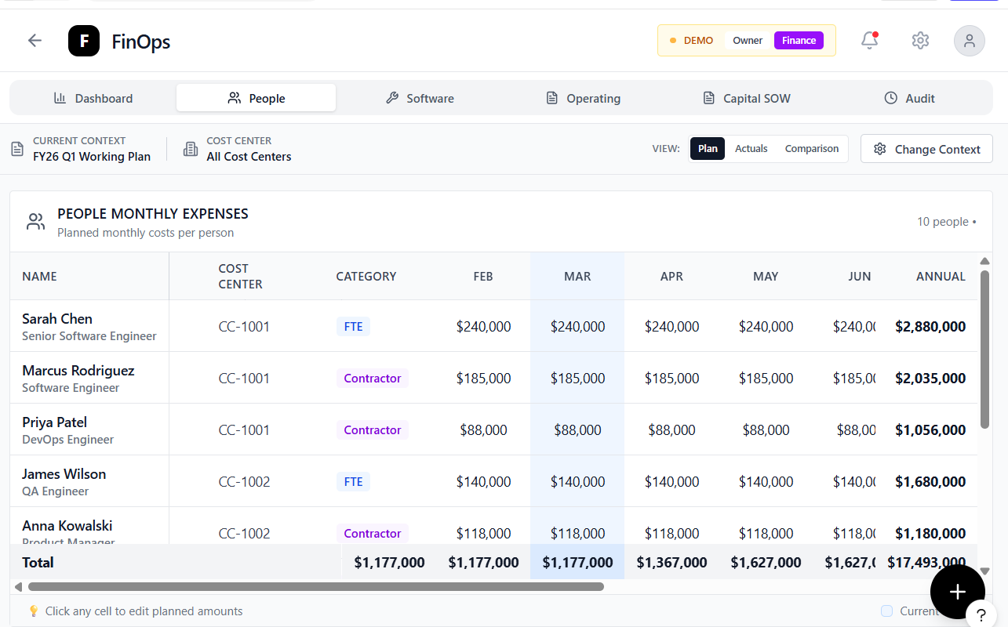

Budget Owner: Software Expenses
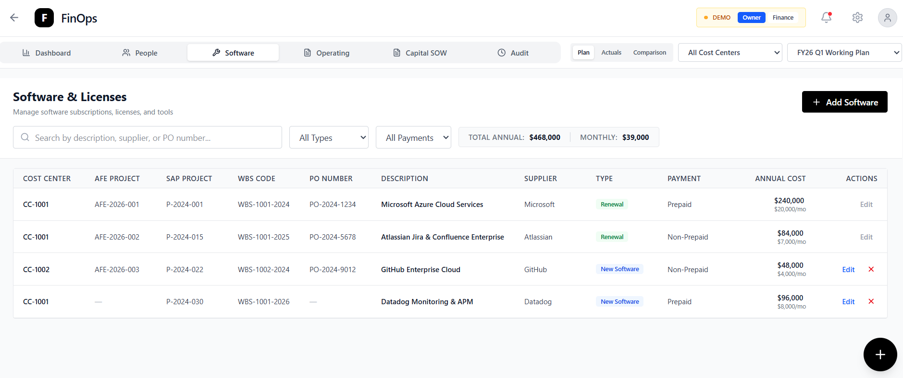

Finance: Software Expenses
Software and Operating Expenses have a similar metadata set and clicking the navigation filters the data. Finance user can expand/collapse the group of Metadata columns to see the expenses in a columnar monthly breakdown
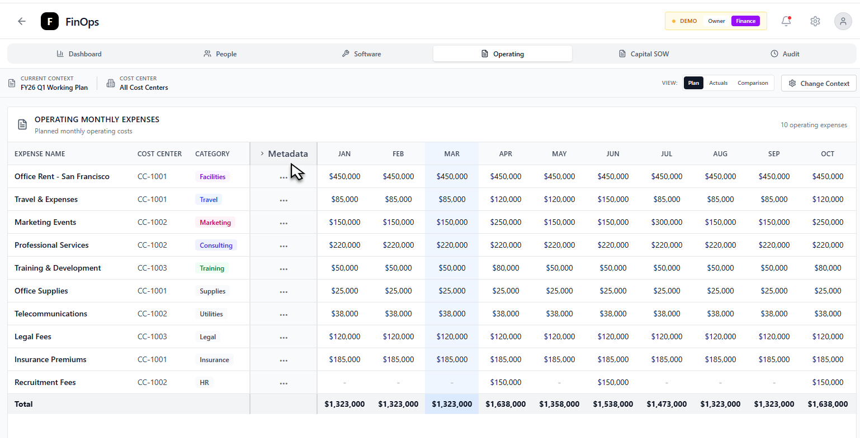
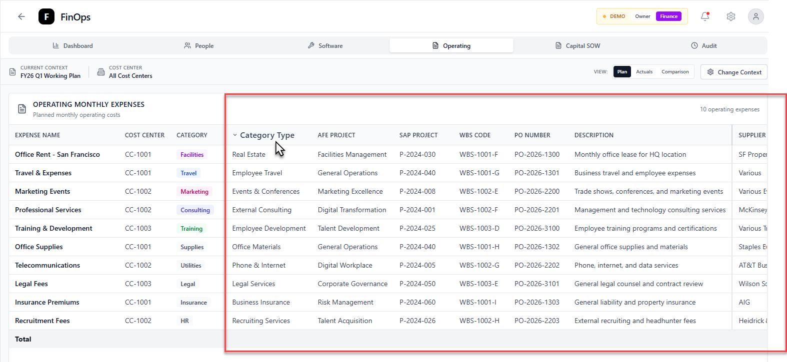

Budget Owner: Operating
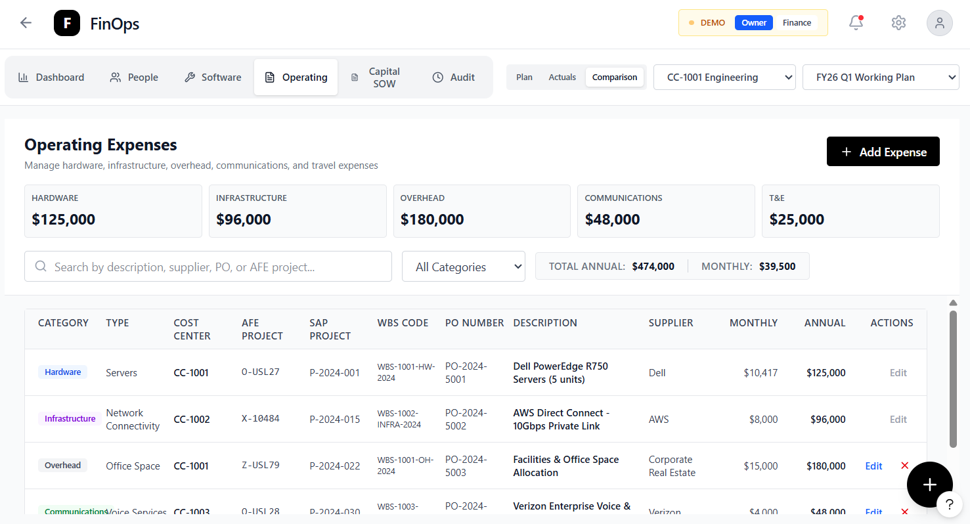

Operating - Add Expense
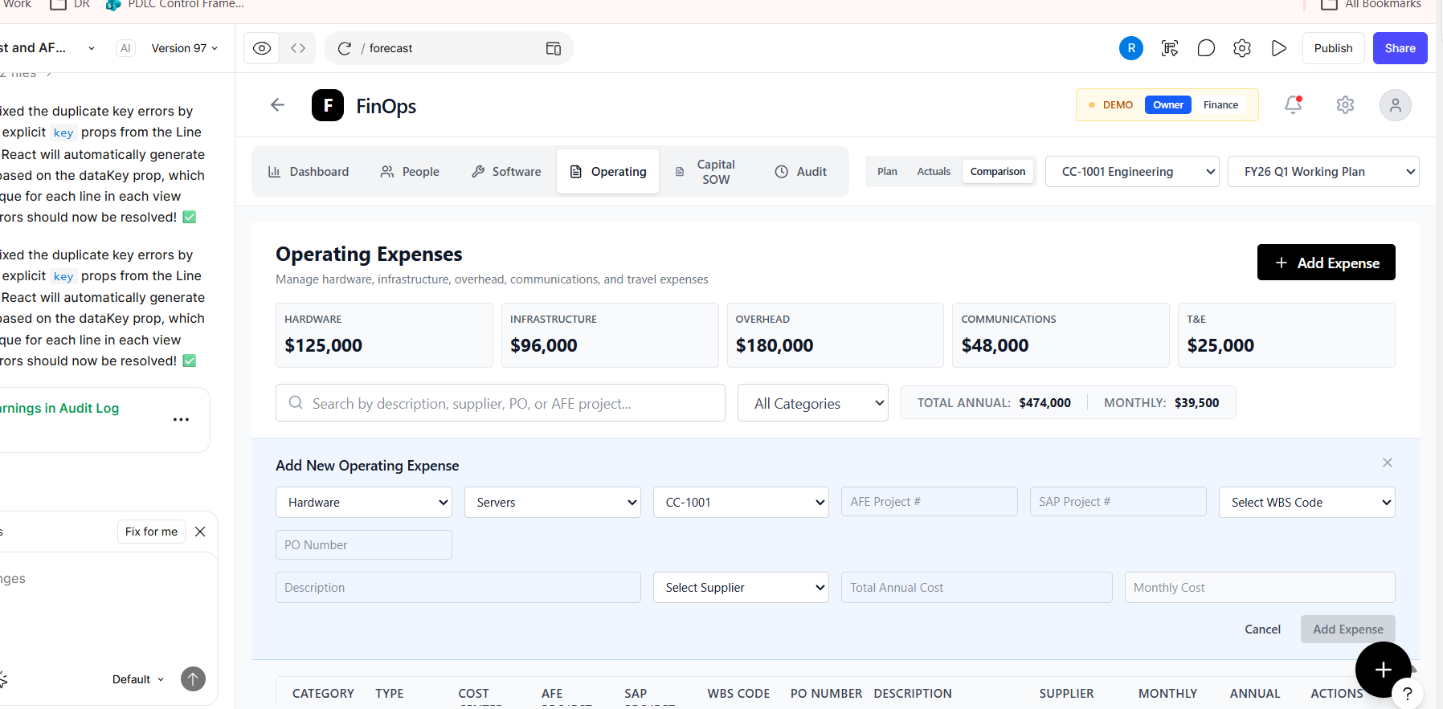

Finance: Operating
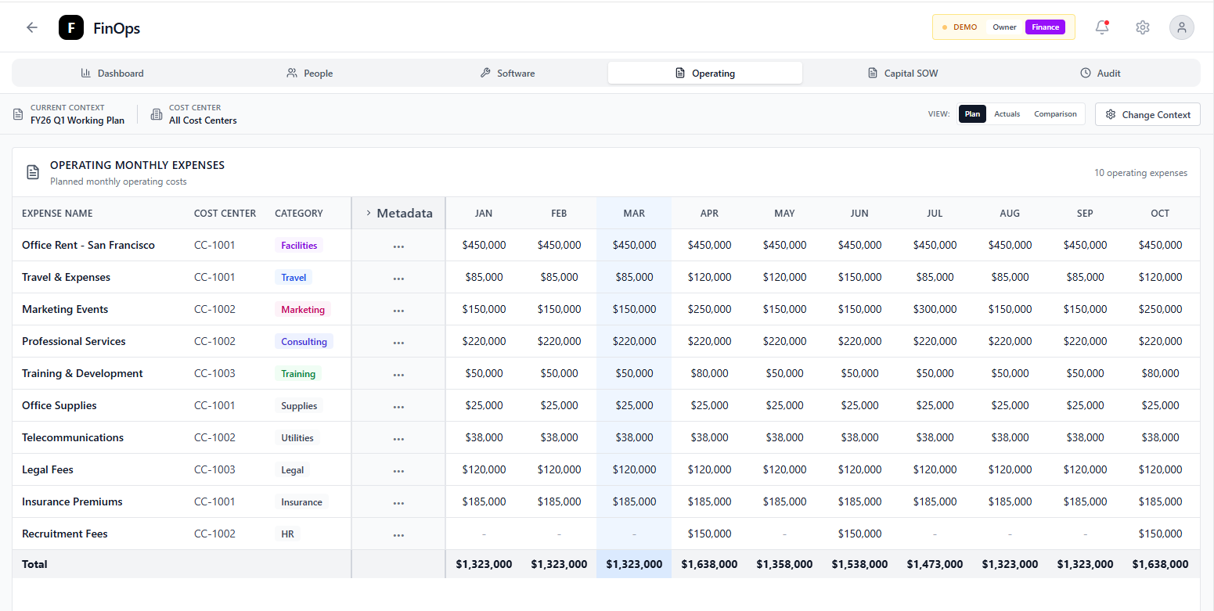

Finance: Capital SOW/ Contracts Matching

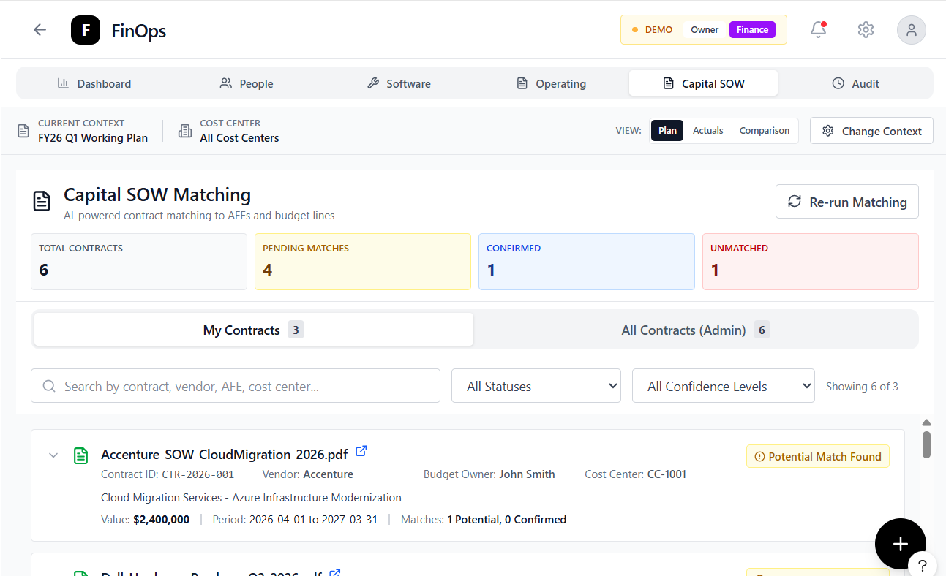

Finance/Budget Owner: Audit
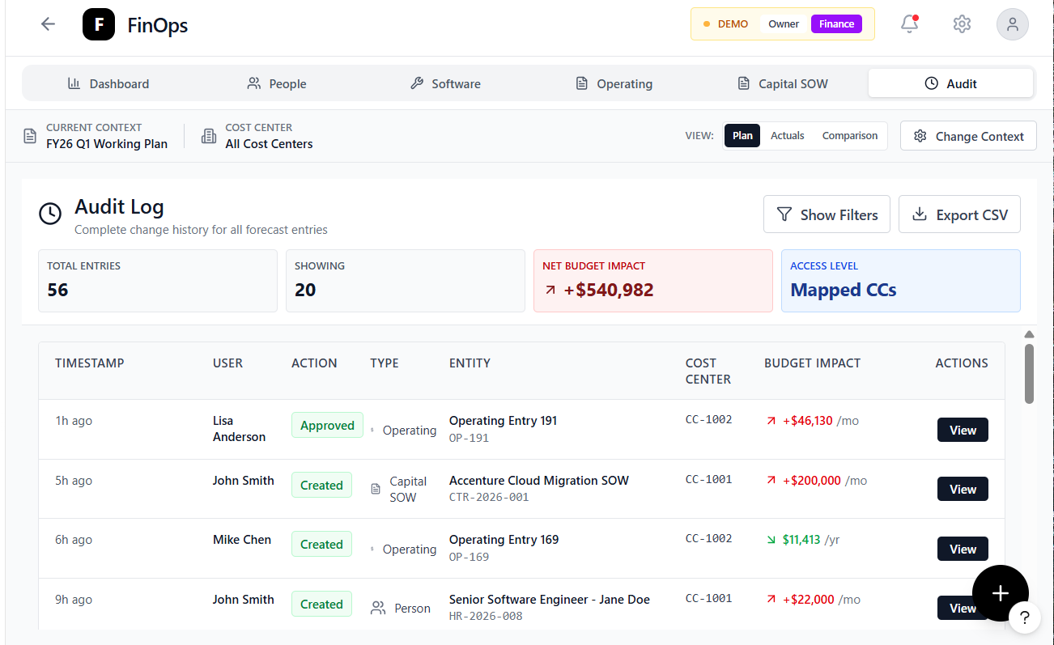

Finance/Budget Owner: Audit View Modal
